<!DOCTYPE html PUBLIC "-//W3C//DTD HTML 4.01 Transitional//EN" "http://www.w3.org/TR/html4/loose.dtd">

<html>

<head>

<script src="https://code.jquery.com/jquery-1.8.2.min.js"></script>

<script src="http://ajax.googleapis.com/ajax/libs/jqueryui/1.9.0/jquery-ui.min.js"></script>

<meta http-equiv="Content-Type" content="text/html; charset=UTF-8">

<meta http-equiv="X-UA-Compatible" content="IE=EmulateIE8" >

<meta http-equiv="Cache-Control" content="No-Cache">

<meta http-equiv="Pragma" content="No-Cache">

<title>JS Bin</title>

</head>

<body>

<table class="table-statistics">

<caption>Application Statistics as of March 15, 2018 6:09 PM</caption>

<thead>

<tr class="row-head">

<th style="text-align:left">Application Status</th>

<th>Non-Member</th>

<th>Member</th>

<th>Total</th>

</tr>

</thead>

<tbody>

<tr style="height:1px"></tr>

<tr class="row-data">

<td class="row-name">Data Entry</td>

<td>25</td>

<td>3</td>

<td>28</td>

</tr>

<tr class="row-data">

<td class="row-name">First Assessment</td>

<td>1</td>

<td>0</td>

<td>1</td>

</tr>

<tr class="row-data">

<td class="row-name">First Verification <label class="sub-name">(new)</label></td>

<td>0</td>

<td>0</td>

<td>0</td>

</tr>

<tr class="row-data">

<td class="row-name">First Verification <label class="sub-name">(pending)</label></td>

<td>0</td>

<td>0</td>

<td>0</td>

</tr>

<tr class="row-data">

<td class="row-name">Survey On Progress</td>

<td>0</td>

<td>1</td>

<td>1</td>

</tr>

<tr class="row-data">

<td class="row-name">Final Verification <label class="sub-name">(new)</label></td>

<td>0</td>

<td>0</td>

<!-- hovered on -->

<td>0</td>

</tr>

<tr class="row-data">

<td class="row-name">Final Verification <label class="sub-name">(pending)</label></td>

<td>0</td>

<td>0</td>

<td>0</td>

</tr>

<tr class="row-data">

<td class="row-name">Final Assessment</td>

<td>0</td>

<td>1</td>

<td>1</td>

</tr>

<tr class="row-data">

<td class="row-name">Settlement <label class="sub-name">(not yet settled)</label></td>

<td>227</td>

<td>146</td>

<td>373</td>

</tr>

<tr class="row-data">

<td class="row-name">Full Entry</td>

<td>97</td>

<td>73</td>

<td>170</td>

</tr>

<tr class="row-data">

<td class="row-name">Sales</td>

<td>33605</td>

<td>10546</td>

<td>44151</td>

</tr>

</tbody>

</table>

</body>

</html>

html, body

{

background-color: #fff;

font-family: Tahoma, sans-serif;

font-size: 11px;

}

table.table-statistics

{

border-collapse: collapse;

text-align: center;

}

table.table-statistics .bg

{

background-color: rgb(255,242,200) !important;

color: black !important;

}

table.table-statistics th

{

border-bottom: 2px solid rgb(64,64,64);

border-style: solid;

border-width: 0px 0px 2px 0px;

padding: 6px 5px 6px 5px;

width: 100px;

}

table.table-statistics td

{

background-color: rgb(242,242,242);

border-color: white;

border-style: solid;

border-width: 0px 2px 2px 0px;

padding: 6px 5px 6px 5px;

}

table.table-statistics td.row-name

{

background-color: rgb(46,117,182);

color: white;

font-weight: bold;

text-align: left;

width: 200px;

}

table.table-statistics td label.sub-name

{

font-size: smaller;

font-weight: normal;

vertical-align: sub;

}

table.table-statistics caption

{

font-weight: bold;

padding-bottom: 5px;

text-align: left;

}

$(document).ready(function() {

$('table.table-statistics .row-data').find('td').not(':first-child').on('mouseenter mouseleave', function() {

var i = $(this).index();

$(this).toggleClass('bg');

$(this).closest('tr').find('td').first().toggleClass('bg');

$('table.table-statistics .row-head th').eq(i).toggleClass('bg');

});

});

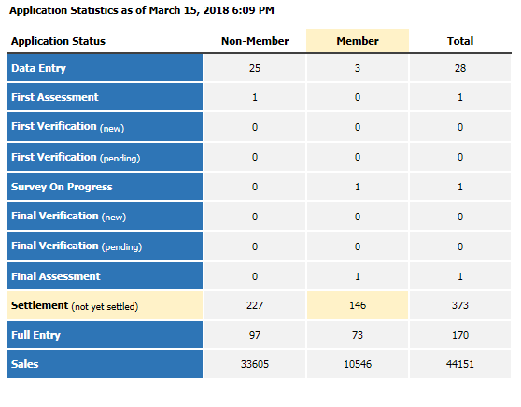

<http://jsbin.com/huyunohulo/1/edit?html,output>